Description on how to use the same ticker list to download historical daily/weekly/monthly data from Alpha Vantage and Yahoo Finance:

Alpha Vantage provides APIs to fetch time series data for stocks as well as physical and digital/crypto currencies. Yahoo symbols for stocks and indices on most exchanges world-wide can also be used with Alpha Vantage APIs. That makes it convenient to use the same ticker list to download historical daily / weekly / monthly data from both Yahoo Finance and Alpha Vantage. You may use the Yahoo server normally, but when Yahoo data is disrupted, you can switch to the “My Web Server (Plus)” and download data from Alpha Vantage.

Users will need to get an API key from Alpha Vantage (https://www.alphavantage.co/) first. Unfortunately the free API key only allows making 5 requests / minute (https://www.alphavantage.co/support/#api-key). If you need to make more frequent requests, please upgrade your API key (https://www.alphavantage.co/premium/).

Please also refer to the “Alpha Vantage API Documentation” to understand what and how data can be downloaded. One key point to note: By default, outputsize=compact. Strings compact and full are accepted with the following specifications: compact returns only the latest 100 data points; full returns the full-length time series of up to 20 years of historical data. The "compact" option is recommended if you would like to reduce the data size of each API call.

Set-up:

- Copy the following line and append to your existing “mywebserver.txt. If your portfolio name is “portfolio1.tic’, change <your-portfolio-name> to portfolio1.

<your-portfolio-name>,https://www.alphavantage.co/query?function=TIME_SERIES_DAILY&symbol=SSSS&outputsize=compact&datatype=csv&apikey=<your-personal-API-key>,DWML1,alphavantage_DWML1(csv).fmt

- Copy the supplied “alphavantage_DWML1(csv).fmt” file to the “fmt” subfolder under the Data File Location (indicated on the Preference screen). If you own an upgrade API key, the myFetchDelay parameter in this file may be set to 0.

- Run HSQuote Plus and use the same ticker symbols as on Yahoo Finance, including world-wide exchanges. Please note again that for free API key, the download speed is 12 seconds for 1 symbol.

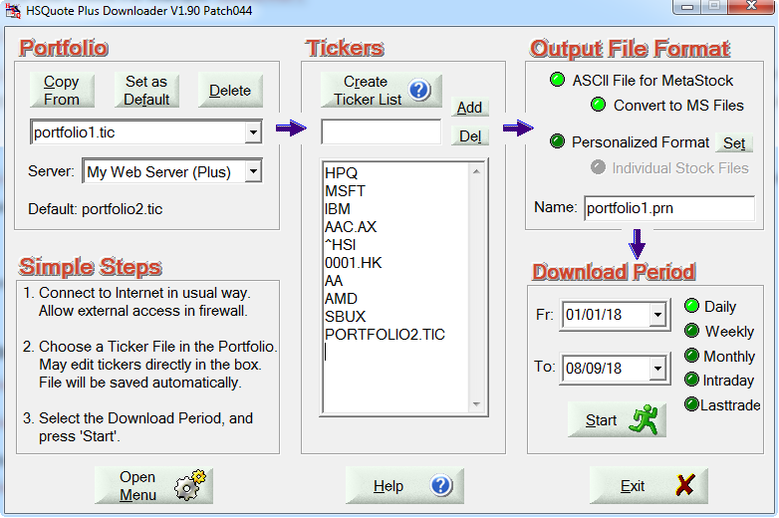
Download:

All you need is just select either the Yahoo server or the “My Web Server (Plus)”, choose the download period, and Start downloading normally. Data will be stored using the ticker symbols (Yahoo symbols).

